**文字放送依頼書**

依頼者：

連絡先：

放送期間：令和　年　月　日より

令和　年　月　日まで

**※分かりやすいよう箇条書きでお願いします。**

**※問い合わせ先（電話番号）を必ず記入してください**。

タイトル（15文字）

|  |  |  |  |  |  |  |  |  |  |  |  |  |  |  |
| --- | --- | --- | --- | --- | --- | --- | --- | --- | --- | --- | --- | --- | --- | --- |
|  |  |  |  |  |  |  |  |  |  |  |  |  |  |  |

本文（15文字×7行）　※箇条書き

|  |  |  |  |  |  |  |  |  |  |  |  |  |  |  |
| --- | --- | --- | --- | --- | --- | --- | --- | --- | --- | --- | --- | --- | --- | --- |
|  |  |  |  |  |  |  |  |  |  |  |  |  |  |  |
|  |  |  |  |  |  |  |  |  |  |  |  |  |  |  |
|  |  |  |  |  |  |  |  |  |  |  |  |  |  |  |
|  |  |  |  |  |  |  |  |  |  |  |  |  |  |  |
|  |  |  |  |  |  |  |  |  |  |  |  |  |  |  |
|  |  |  |  |  |  |  |  |  |  |  |  |  |  |  |
|  |  |  |  |  |  |  |  |  |  |  |  |  |  |  |

問い合わせ先

|  |  |  |  |  |  |  |  |  |  |  |  |  |  |  |
| --- | --- | --- | --- | --- | --- | --- | --- | --- | --- | --- | --- | --- | --- | --- |
|  |  |  |  |  |  |  |  |  |  |  |  |  |  |  |
|  |  |  |  |  |  |  |  |  |  |  |  |  |  |  |

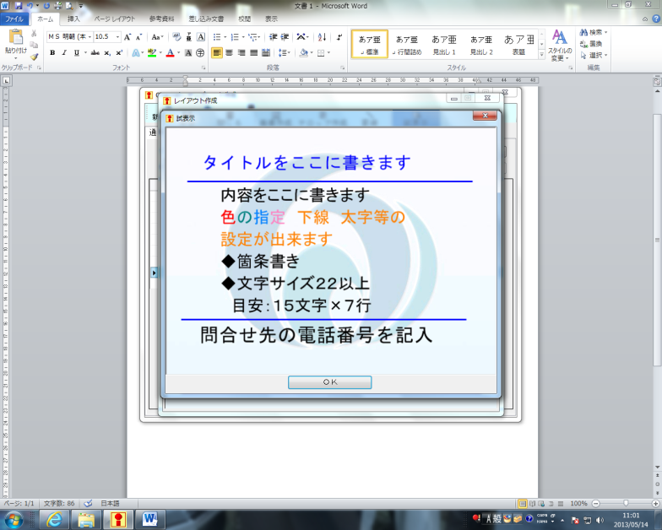

サンプル